# Barton Chapel elementary

## 2022–2023 2nd GRADE SCHOOL SUPPLY LIST

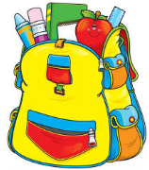

* 1 back-pack (No wheels)
* 4 Spiral Notebooks (math, reading, science, social studies)
* 1 folder (durable)
* 1 pair of scissors
* Glue Sticks (6 or more)
* Pencil pouch or box
* 2 12 count #2 pencils
* 1box of **12 count**-colored pencils OR 24 count crayons **only**
* 2 **12oz** hand sanitizers – ***ONLY BOYS BRING IN***
* 3 Tissue boxes – ***ONLY GIRLS BRING IN***
* 1 set of headphones or earphones

Optional:

* 1 pack of Cardstock (Teacher use)
* Ziplock bags (gallon or sandwich size)
* Baby wipes

This is going to be a terrific year! I cannot wait to meet every wonderful face!

Thank you,

Mrs. Carnley